PART-A
PRACTICAL 1:
Aim: Create your class time table using table tag.
Source Code:
<html>
<head>
<title> FYBCA Timetable </title>
</head>
<body>
<h1 align="center"> Revised Time Table </h1>
<h2 align="center"> 2nd Sem FYBCA-A </h2>
<table border="1" cellspacing="0" cellpadding="5" align="center">
<tr>
<th> TIME/DAY </th>
<th> MONDAY </th>
<th> TUESDAY </th>
<th> WEDNESDAY </th>
<th> THURSDAY </th>
<th> FRIDAY </th>
<th> SATURDAY </th>
</tr>

<tr>
<td> 9:30-10:30 </td>
<td> C.C </td>
<td> Kskool </td>
<td> </td>
<td> WEB </td>
<td> JAVA </td>
<td> WEB </td>
</tr>

<tr>
<td> 10:30-11:30 </td>
<td> C.C </td>
<td> OS </td>
<td> OS </td>
<td> MATH </td>
<td> WEB </td>
<td> MATH </td>
</tr>

<tr>
<td> 11:30-12:30 </td>
<td> C.C </td>
<td> DS </td>
<td> JAVA </td>
<td> IC </td>
<td> WEB B-1 L2 / OS B-2 L6 </td>
<td> DS </td>
</tr>

<tr>
<td> 12:30-1:30 </td>
<td> C.C </td>
<td> JAVA </td>
<td> IC </td>
<td> DS </td>
<td> WEB B-1 L2 / OS B-2 L6 </td>
<td> OS </td>
</tr>

<tr>
<td colspan="7" align="center"> BREAK </td>
</tr>

<tr>
<td> 1:45-3:45 </td>
<td> C.C </td>
<td> </td>
<td> JAVA B-1 L5 / DS B-2 L6 </td>
<td> JAVA B-2 L5 / DS B-1 L6 </td>
<td> </td>
<td> WEB B-2 L2 / OS B-1 L6 </td>
</tr>
</table>
<h2 align="center"> FYBCA-B </h2>
<table border="1" cellspacing="0" cellpadding="5" align="center">
<tr>
<th> TIME/DAY </th>
<th> MONDAY </th>
<th> TUESDAY </th>
<th> WEDNESDAY </th>
<th> THURSDAY </th>
<th> FRIDAY </th>
<th> SATURDAY </th>
</tr>

<tr>
<td> 9:30-10:30 </td>
<td> C.C </td>
<td> Kskool </td>
<td> DS B-1 L1 </td>
<td> DS B-1 L1 </td>
<td> JAVA </td>
<td> </td>
</tr>

<tr>
<td> 10:30-11:30 </td>
<td> C.C </td>
<td> DS </td>
<td> IC </td>
<td> DS </td>
<td> MATH </td>
<td> WEB </td>
</tr>

<tr>
<td> 11:30-12:30 </td>
<td> C.C </td>
<td> JAVA </td>
<td> MATH </td>
<td> WEB </td>
<td> DS </td>
<td> JAVA </td>
</tr>

<tr>
<td> 12:30-1:30 </td>
<td> C.C </td>
<td> OS </td>
<td> OS </td>
<td> OS </td>
<td> WEB </td>
<td> DS B-2 L2 </td>
</tr>
<tr>
<td colspan="7" align="center"> BREAK </td>
</tr>
<tr>
<td> 1:45-2:45 </td>
<td> C.C </td>
<td> WEB B-2 L4 / OS B-1 L5 </td>
<td> JAVA B-1 L4 / DS B-2 L6 </td>
<td> IC </td>
<td> WEB B-1 L5 / JAVA B-2 L4 </td>
<td> DS B-2 L2 </td>
</tr>

<tr>
<td> 2:45-3:45 </td>
<td> C.C </td>
<td> WEB B-2 L4 / OS B-1 L5 </td>
<td> JAVA B-1 L4 / DS B-2 L6 </td>
<td> </td>
<td> WEB B-1 L5 / JAVA B-2 L4 </td>
<td> </td>
</tr>
</table>
</body>
</html>

Output:

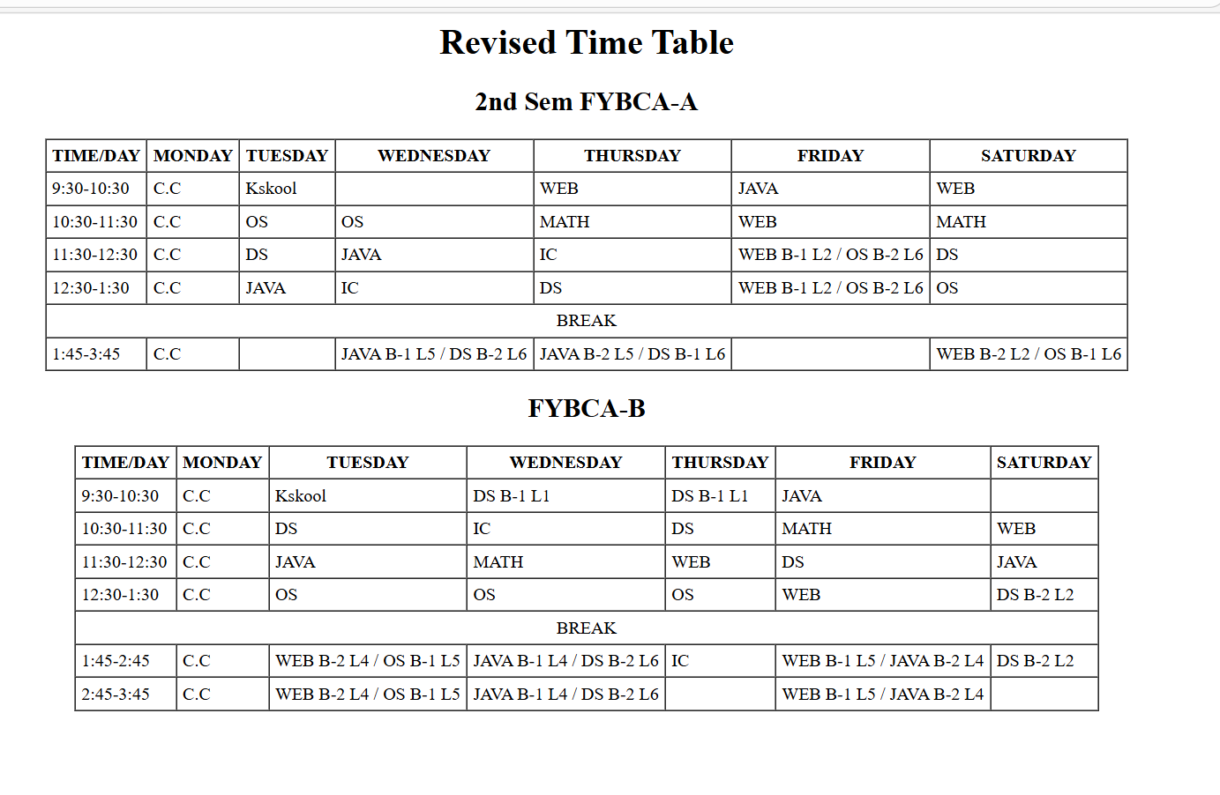

PRACTICAL 2:
Aim: Design a Webpage for your college containing description of courses, department, faculties, library etc. using list tags, href tags, and anchor tags.
Source Code:
<html>
<head>
<title>My College Website</title>
</head>
<body>
<h1 align="center">Welcome to KES SHROFF College</h1>
<h3>Quick Links</h3>
<ul>
<li><a href="#courses">Courses</a></li>
<li><a href="#departments">Departments</a></li>
<li><a href="#faculties">Faculties</a></li>
<li><a href="#library">Library</a></li>
<li><a href="https://www.google.com" target="https://kessc.edu.in/">Visit Official Website</a></li>
</ul>
<hr>
<h2 id="courses">Courses Offered</h2>
<ol>
<li>BCA (Bachelor of Computer Applications)</li>
<li>BBA (Bachelor of Business Administration)</li>
<li>B.Com (Bachelor of Commerce)</li>
<li>BA (Bachelor of Arts)</li>
</ol>
<p>Our college offers a variety of undergraduate and postgraduate courses designed to build strong academic and practical knowledge.</p>
<hr>
<h2 id="departments">Departments</h2>
<ul>
<li>Computer Science Department</li>
<li>Commerce Department</li>
<li>Management Department</li>
<li>Arts Department</li>
</ul>
<p>Each department is equipped with experienced staff and modern facilities.</p>
<hr>
<h2 id="faculties">Faculties</h2>
<ul>
<li>Dr. Sanjay Mishra</li>
<li>Ms. Dhanashree Bhanushali</li>
<li>Mr. Nitish Kumar</li>
<li>Ms. Snehlata Agarwal</li>
</ul>
<p>Our faculties are highly qualified and dedicated to student success.</p>
<hr>
<h2 id="library">Library</h2>
<ul>
<li>More than 10,000 books</li>
<li>Digital Library Access</li>
<li>Reading Hall</li>
<li>Journals and Magazines</li>
</ul>
<p>The library provides a peaceful environment for study and research.</p>
<hr>
<a href="#top">Go to Top</a>
</body>
</html>
Output:
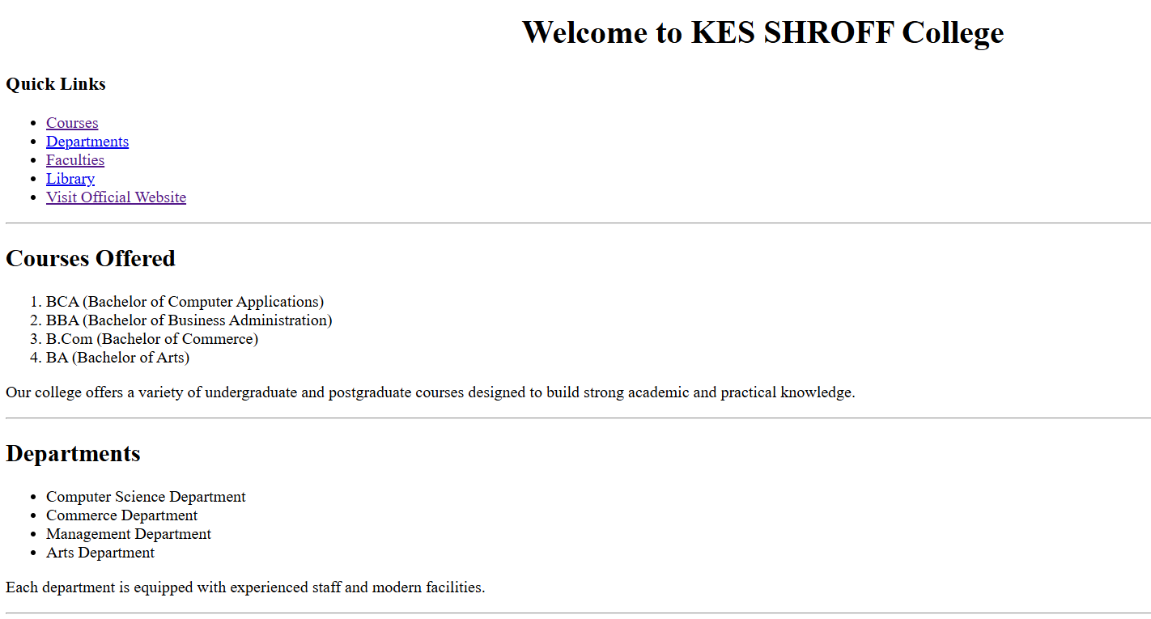
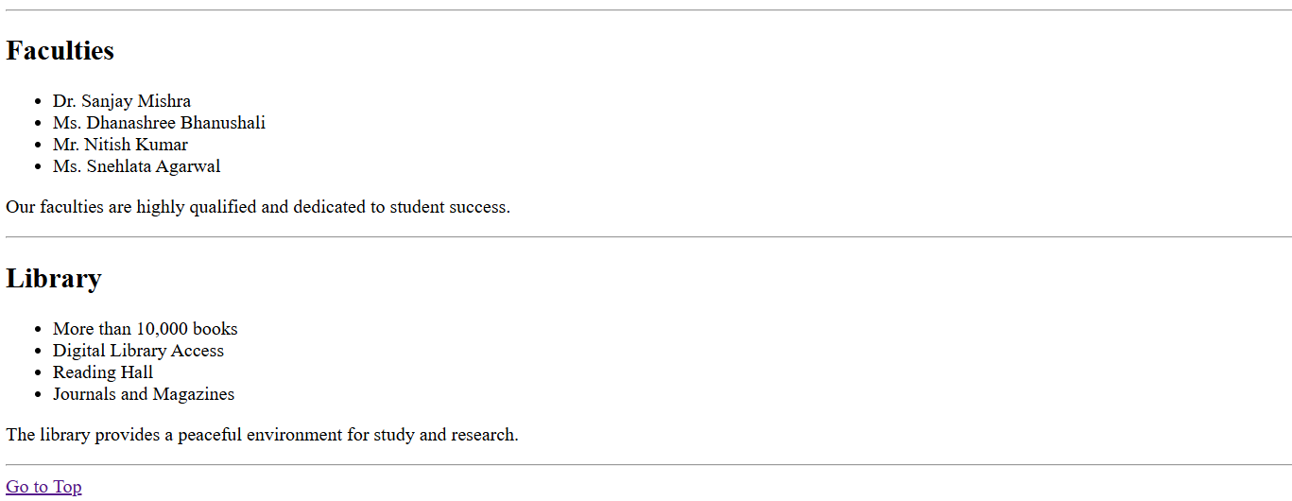
PRACTICAL 3:
Aim: Create web page using Frame with rows and columns where we will have header frame, left frame, right frame, and status bar frame. On clicking in the left frame, information should be displayed in right frame.
Source Code:
<html>
<head>
<title>College Frame Layout</title>
</head>
<body>
<div style="background-color: lightblue; text-align: center; padding: 15px;">
<h1>KES SHROFF COLLEGE</h1>
</div>
<div style="display: flex; height: 400px;">
<div style="width: 30%; background-color: lightgray; padding: 10px;">
<h3>Menu</h3>
<ul>
<li><a href="#" onclick="loadContent('courses')">Courses</a></li>
<li><a href="#" onclick="loadContent('departments')">Departments</a></li>
<li><a href="#" onclick="loadContent('faculties')">Faculties</a></li>
<li><a href="#" onclick="loadContent('library')">Library</a></li>
</ul>
</div>
<div id="rightFrame" style="width: 70%; padding: 20px;">
<h2>Welcome to KES SHROFF COLLEGE</h2>
<p>Select an option from the left menu.</p>
</div>
</div>
<div style="background-color: lightgreen; text-align: center; padding: 10px;">
<marquee>Welcome to KES SHROFF College Website</marquee>
</div>
<script>
function loadContent(section) {
let content = "";
if (section === "courses") {
content = "<h2>Courses Offered</h2><ul><li>BCA</li><li>BBA</li><li>B.Com</li></ul>";
}
else if (section === "departments") {
content = "<h2>Departments</h2><ul><li>Computer Science</li><li>Commerce</li><li>Management</li></ul>";
}
else if (section === "faculties") {
content = "<h2>Faculties</h2><ul><li>Dr. Sharma</li><li>Prof. Khan</li><li>Mrs. Patel</li></ul>";
}
else if (section === "library") {
content = "<h2>Library</h2><p>Our library has books, journals, and digital resources. </p>";
}
document.getElementById("rightFrame").innerHTML = content;
}
</script>
</body>
</html>

Output:
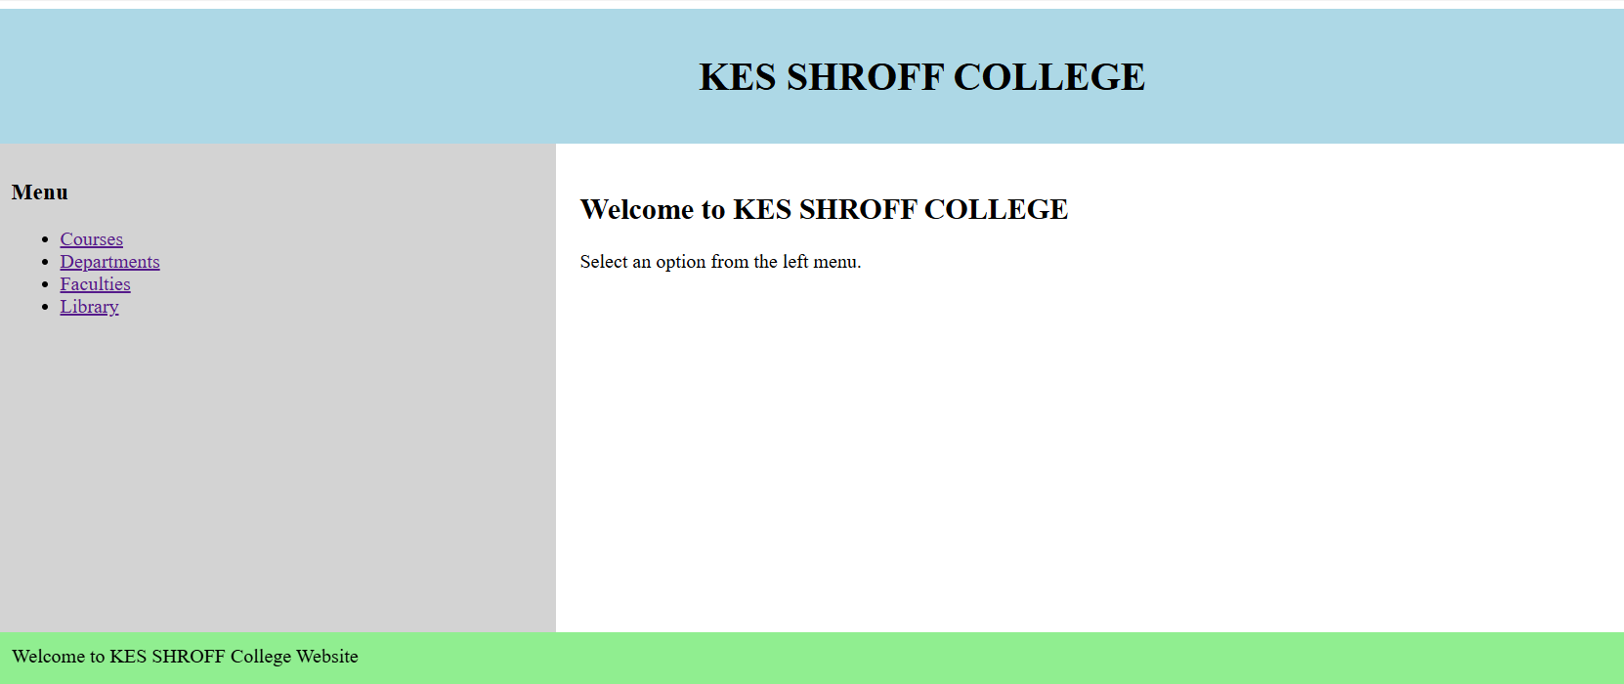

PRACTICAL 4 AND 6:
Aim: Create Your Resume using HTML, use text, link, size, color and lists.
Aim: Use Inline CSS to format your resume that you have created.
Source Code:
<html>
<head>
<title>My Resume</title>
</head>
<body bgcolor="lightyellow">
<h1 align="center"><font color="blue">My Resume</font></h1>
<h2><font color="darkred">Personal Information</font></h2>
<p><b>Name:</b> Iqra Siddiqui</p>
<p><b>Email:</b> <a href="mailto:iqrasidd09@gmail.com">iqrasidd09@gmail.com</a></p>
<p><b>Phone:</b> 7506959935</p>
<hr>
<h2><font color="darkred">Career Objective</font></h2>
<p>
To obtain a challenging position where I can use my skills and grow professionally.
</p>
<hr>
<h2><font color="darkred">Education</font></h2>
<ul>
<li>BCA - KES SHROFF COLLEGE</li>
<li>HSC - BISHOP JOHNSON SCHOOL AND COLLEGE</li>
<li>SSC - BISHOP JOHNSON SCHOOL</li>
</ul>
<hr>
<h2><font color="darkred">Skills</font></h2>
<ul>
<li>HTML, CSS, JavaScript</li>
<li>C, C++ Programming</li>
<li>Basic Java</li>
</ul>
<hr>
<h2><font color="darkred">Projects</font></h2>
<ol>
<li>College Website using HTML</li>
<li>Student Management System</li>
</ol>
<hr>
<h2><font color="darkred">Hobbies</font></h2>
<ul>
<li>Reading</li>
<li>Traveling</li>
<li>Listening to Music</li>
</ul>
<hr>
<h2><font color="darkred">Links</font></h2>
<p>
Visit my LinkedIn:
<a href="https://www.linkedin.com" target="_blank">Click Here</a>
</p>
<hr>
<h2><font color="darkred">Declaration</font></h2>
<p>
I hereby declare that the above information is true to the best of my knowledge.
</p>

</body>
</html>
Output:
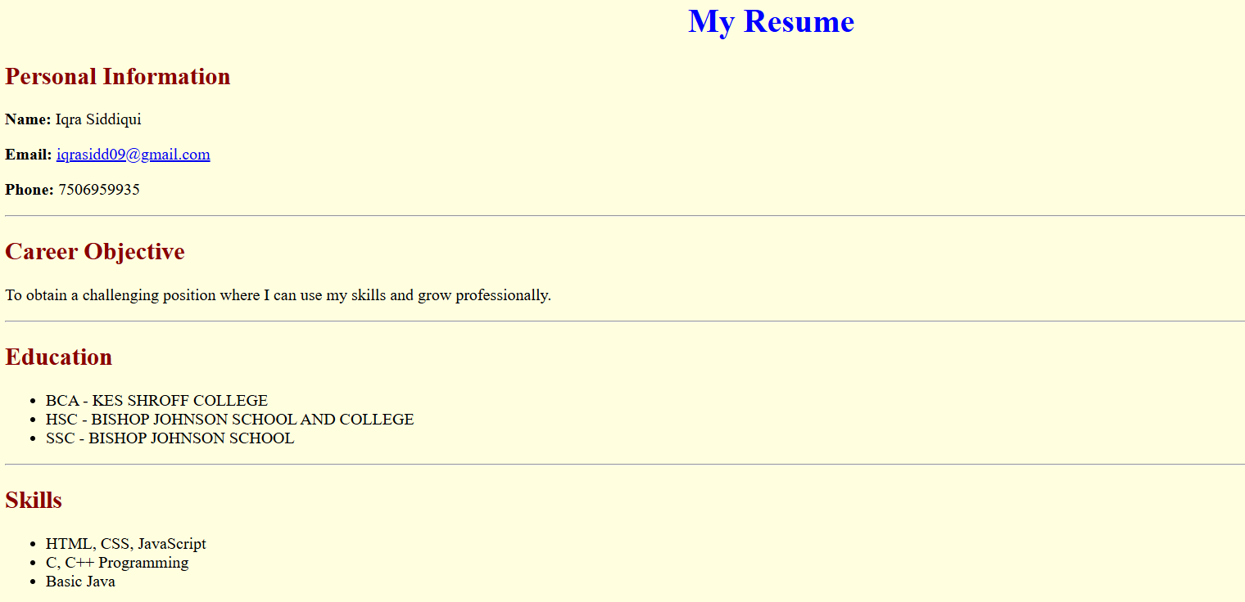
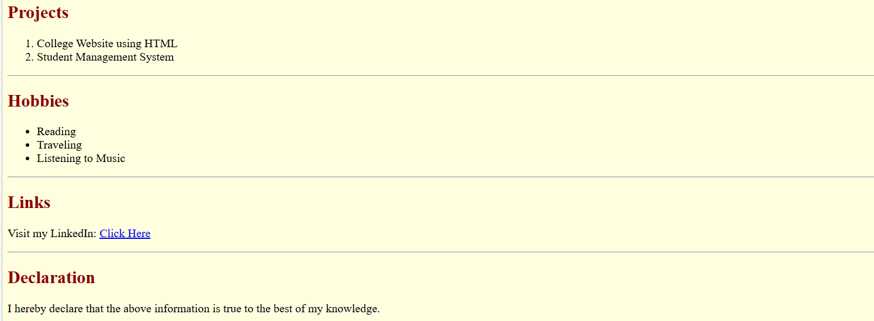

PRACTICAL 5:
Aim: Create a Web Page of a super market using (internal CSS)
Source Code:
<html>
<head>
<title>Super Market</title>
<style>
body {
font-family: Arial;
background-color: #f2f2f2;
margin: 0;
}
header {
background-color: green;
color: white;
text-align: center;
padding: 15px;
}
nav {
background-color: #333;
padding: 10px;
text-align: center;
}
nav a {
color: white;
text-decoration: none;
margin: 15px;
font-size: 18px;
}
nav a:hover {
color: yellow;
}

.container {
padding: 20px;
}
.section {
background-color: white;
padding: 15px;
margin: 15px 0;
border-radius: 10px;
box-shadow: 0 0 5px gray;
}
h2 {
color: green;
}
ul {
list-style-type: square;
}
footer {
background-color: green;
color: white;
text-align: center;
padding: 10px;
}
</style>
</head>
<body>
<header>
<h1>Fresh Mart Super Market</h1>
<p>Your One Stop Grocery Store</p>
</header>
<nav>
<a href="#fruits">Fruits</a>
<a href="#vegetables">Vegetables</a>
<a href="#dairy">Dairy</a>
<a href="#offers">Offers</a>
</nav>
<div class="container">
<div class="section" id="fruits">
<h2>Fruits</h2>
<ul>
<li>Apples</li>
<li>Bananas</li>
<li>Mangoes</li>
<li>Oranges</li>
</ul>
</div>
<div class="section" id="vegetables">
<h2>Vegetables</h2>
<ul>
<li>Potatoes</li>
<li>Tomatoes</li>
<li>Onions</li>
<li>Carrots</li>
</ul>
</div>
<div class="section" id="dairy">
<h2>Dairy Products</h2>
<ul>
<li>Milk</li>
<li>Cheese</li>
<li>Butter</li>
<li>Curd</li>
</ul>
</div>
<div class="section" id="offers">
<h2>Special Offers</h2>
<p>Get 20% discount on all fruits this weekend!</p>
</div>
</div>
<footer>
<p>© 2026 Fresh Mart Super Market</p>
</footer>
</body>
</html>

Output:

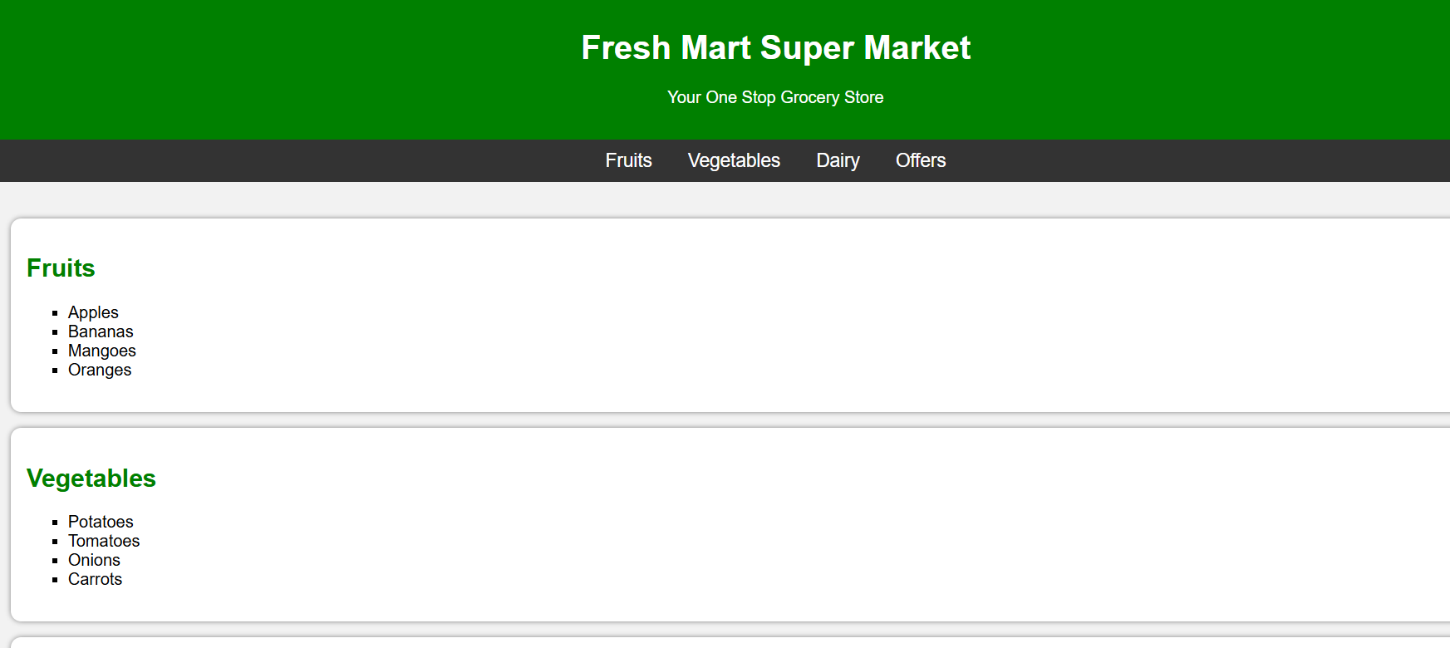
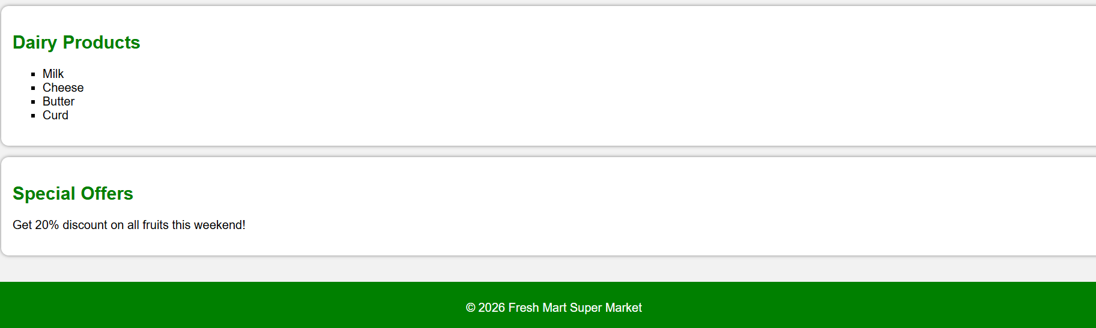

PRACTICAL 7:
Aim: Use External CSS to format your time table created.
Source Code:
body {
font-family: Arial;
background-color: #f4f6f7;
}

h1, h2 {
text-align: center;
color: darkblue;
}

table {
width: 80%;
margin: 20px auto;
border-collapse: collapse;
background-color: white;
}

th {
background-color: #2e86c1;
color: white;
padding: 10px;
}

td {
text-align: center;
padding: 8px;
}

table, th, td {
border: 1px solid black;
}

/* Alternate row color */
tr:nth-child(even) {
background-color: #f2f2f2;
}

/* Break row styling */
.break {
background-color: #f39c12;
color: white;
font-weight: bold;
}
Output:
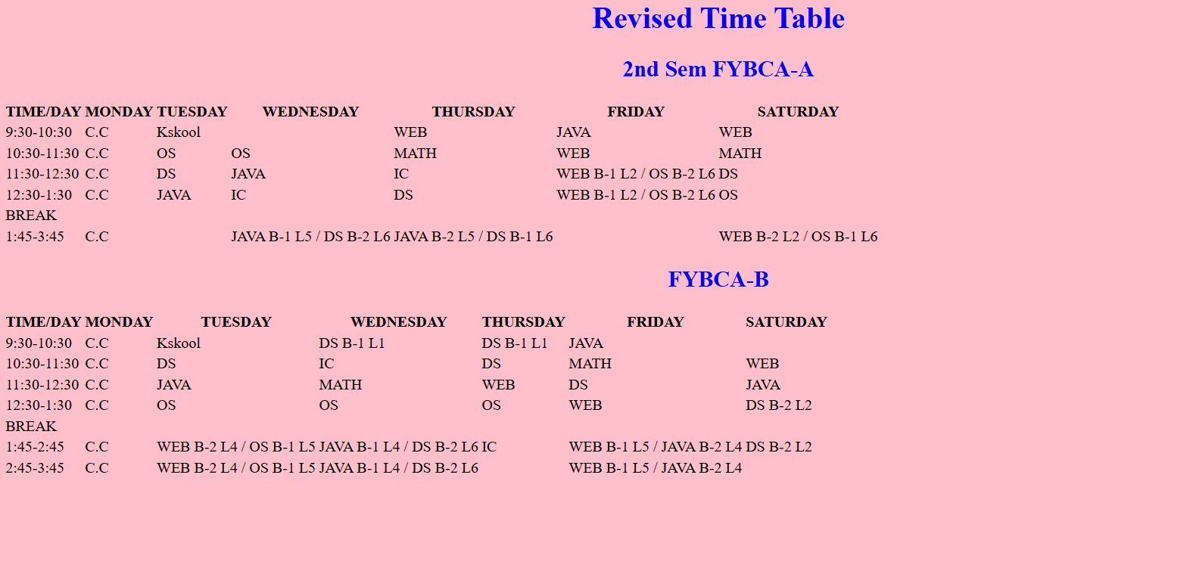

PRACTICAL 8:
Aim: Use all the CSS (inline, internal andexternal) to format college web page that you have created.
Source Code:
<html>
<head>
<title>KES SHROFF COLLEGE</title>
<link rel="stylesheet" href="style.css">
<style>
body {
background-color: Pink;
}

h2 {
color: darkblue;
text-decoration: underline;
}

.section {
padding: 15px;
margin: 15px;
border-radius: 10px;
}
</style>
</head>

<body>
<h1 style="text-align:center; color: green;">KES SHROFF COLLEGE</h1>
<div class="section">
<a href="#courses">Courses</a> |
<a href="#departments">Departments</a> |
<a href="#faculties">Faculties</a> |
<a href="#library">Library</a>
</div>
<div class="section" id="courses" style="background-color: pink;">
<h2>Courses</h2>
<ul>
<li>BCA</li>
<li>BBA</li>
<li>B.Com</li>
</ul>
</div>
<div class="section" id="departments" style="background-color: pink;">
<h2>Departments</h2>
<ul>
<li>Computer Science</li>
<li>Commerce</li>
<li>Management</li>
</ul>
</div>
<div class="section" id="faculties" style="background-color: pink;">
<h2>Faculties</h2>
<ul>
<li>Dr. Sanjay Mishra</li>
<li>Ms. Dhanashree Bhanushali</li>
<li>Mr. Nitish Kumar</li>
</ul>
</div>
<div class="section" id="library" style="background-color: pink;">
<h2>Library</h2>
<p>Our library contains books, journals and digital resources.</p>
</div>
<footer style="text-align:center; background-color:black; color:white; padding:10px;">
© 2026 KES SHROFF COLLEGE
</footer>

</body>
</html>
Output:
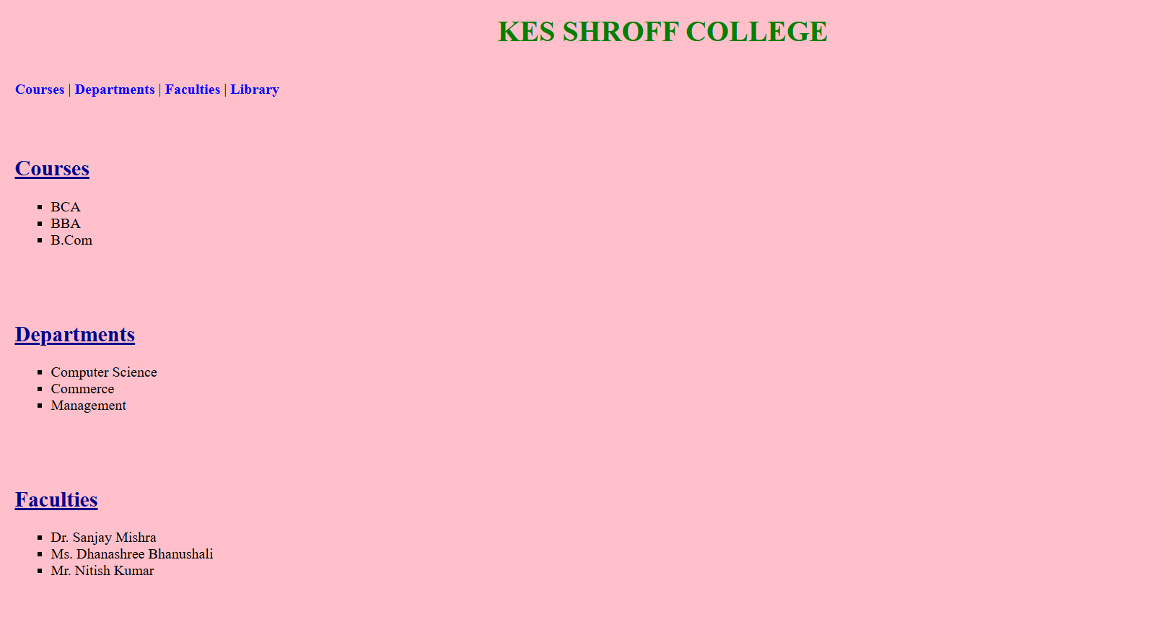
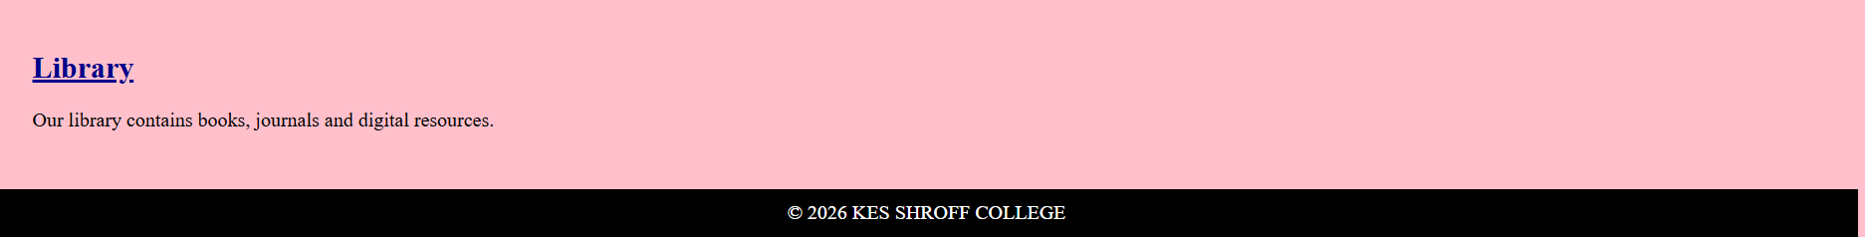

PRACTICAL 9:
Aim: Write a HTML Program to create your college website using for
mobile device.
Source Code:
<html>
<head>
<title>KES SHROFF COLLEGE</title>
<meta name="viewport" content="width=device-width, initial-scale=1.0">
<style>
body {
font-family: Arial;
margin: 0;
background-color: Brown;
}
header {
background-color: green;
color: white;
text-align: center;
padding: 15px;
}

nav {
background-color: Brown;
text-align: center;
padding: 10px;
}

nav a {
color: white;
display: block;
padding: 10px;
text-decoration: none;
border-bottom: 1px solid #555;
}

nav a:hover {
background-color: green;
}

.container {
padding: 15px;
}

.section {
background-color: white;
margin-bottom: 15px;
padding: 15px;
border-radius: 10px;
}

h2 {
color: green;
}

ul {
padding-left: 20px;
}

footer {
background-color: green;
color: white;
text-align: center;
padding: 10px;
}

/* Responsive Design (for larger screens) */
@media (min-width: 768px) {
nav a {
display: inline-block;
border: none;
margin: 5px;
}
}
</style>
</head>
<body>
<header>
<h1>KES SHROFF COLLEGE</h1>
<p>Welcome to Our Mobile Website</p>
</header>
<nav>
<a href="#courses">Courses</a>
<a href="#departments">Departments</a>
<a href="#faculties">Faculties</a>
<a href="#library">Library</a>
</nav>
<div class="container">
<div class="section" id="courses">
<h2>Courses</h2>
<ul>
<li>BCA</li>
<li>BBA</li>
<li>B.Com</li>
</ul>
</div>
<div class="section" id="departments">
<h2>Departments</h2>
<ul>
<li>Computer Science</li>
<li>Commerce</li>
<li>Management</li>
</ul>
</div>

<div class="section" id="faculties">
<h2>Faculties</h2>
<ul>
<li>Dr. Sanjay Mishra</li>
<li>Ms. Dhanashree Bhanushali</li>
<li>Mr. Nitish Kumar</li>
</ul>
</div>
<div class="section" id="library">
<h2>Library</h2>
<p>Our library provides books, journals and digital resources.</p>
</div>
</div>
<footer>
<p>© 2026 KES SHROFF COLLEGE</p>
</footer>
</body>
</html>
Output:
